When Groups Start Fragmenting into Subgroups

Mary Davies
Shake Seigel
Iain Lamb

How do the individual members and subgroups affect the dynamic?

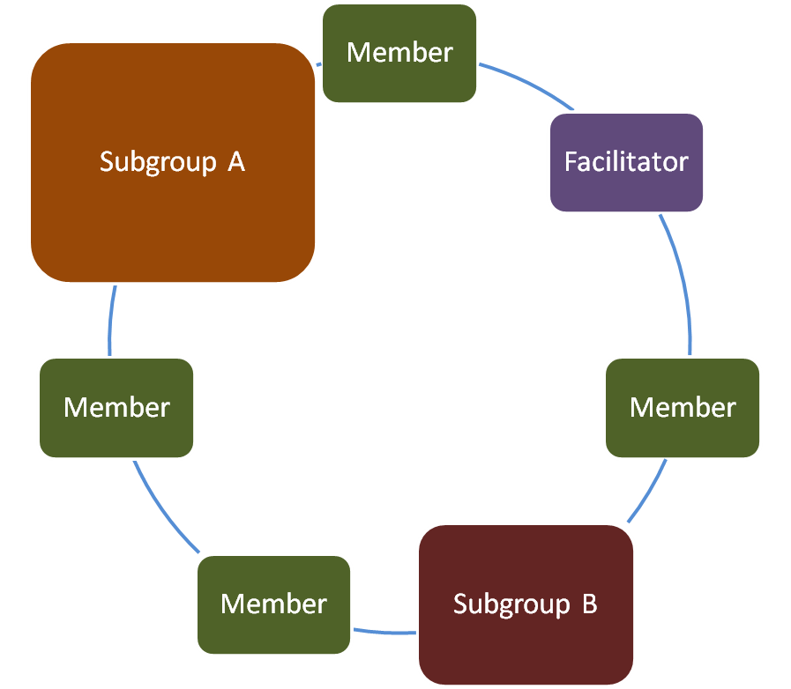
A subgroup is a collection of the group members who have in some way formed an alliance, which will affect the group dynamic, and this may be in a positive, neutral, or negative way.

A subgroup of group members will usually sit together, talk together at refreshment breaks, and may have a life together outside the group.

Other group members may be drawn towards them, or may be upset by their power.

The subgroup may have been formed before the group started together; for example, a group working together on something else on the outside, or a married couple. It is important to acknowledge this early on in the forming of the group; a round early on of ‘any alliances within the group?’ can make it obvious to the others.

Sometimes a subgroup will form in response to a challenge within the group.
A group of young doctors were working together. In the group were two male doctors who were very humorous, but some of the jokes they told at coffee time were bordering on sexist. Three of the female doctors did not like this, and took to sitting together, and exchanging looks whenever one of the jokers started talking. I had to raise the issue of what was happening in the group, and re visit the group rule about mutual respect.

Sometimes members (particularly International Medical Graduates) set up cultural subgroups. You can understand why: sometimes they don’t feel they ‘fit in’ with others and want to ‘belong’ to a group who have similar feelings and experiences for future mutual support. Whilst not necessarily a bad thing, this can sometimes lead to a loss of interaction with other members of a group, thus limiting their future learning and possibly learning bad habits from each other. Acknowledging these can enable a breaking down of barriers.
A group of GP trainees were meeting on a regular basis. Initially there was a good mixing of the members. Over a couple of weeks, it became apparent that a group of the male GP trainees had separated themselves from the other male GP trainees , with whom they had previously been friendly.

It came up in discussion, that the subgroup had felt ostracised because they could not take part in the ongoing chats about cricket that were preoccupying the others, as it was outside their culture, and they did not know anything about the game or the vocabulary.

This led to a sharing of views and facts about each other’s cultures which was educational for all involved.

It is important that you discuss the effect that the subgroups are having on the group. Do this with the group members and within the group, especially if it is having a negative effect on the dynamic. This is an instance when you need to raise the process issues going on in the group, if you want to allow the previous level of task and support to be regained.

And don’t forget that sometimes a subgroup can have a very positive effect on the dynamic. A subgroup of enthusiastic participants, keen and eager to learn and share will influence the more reluctant group members.

